MEDIA RELEASE

1 AUG 2024

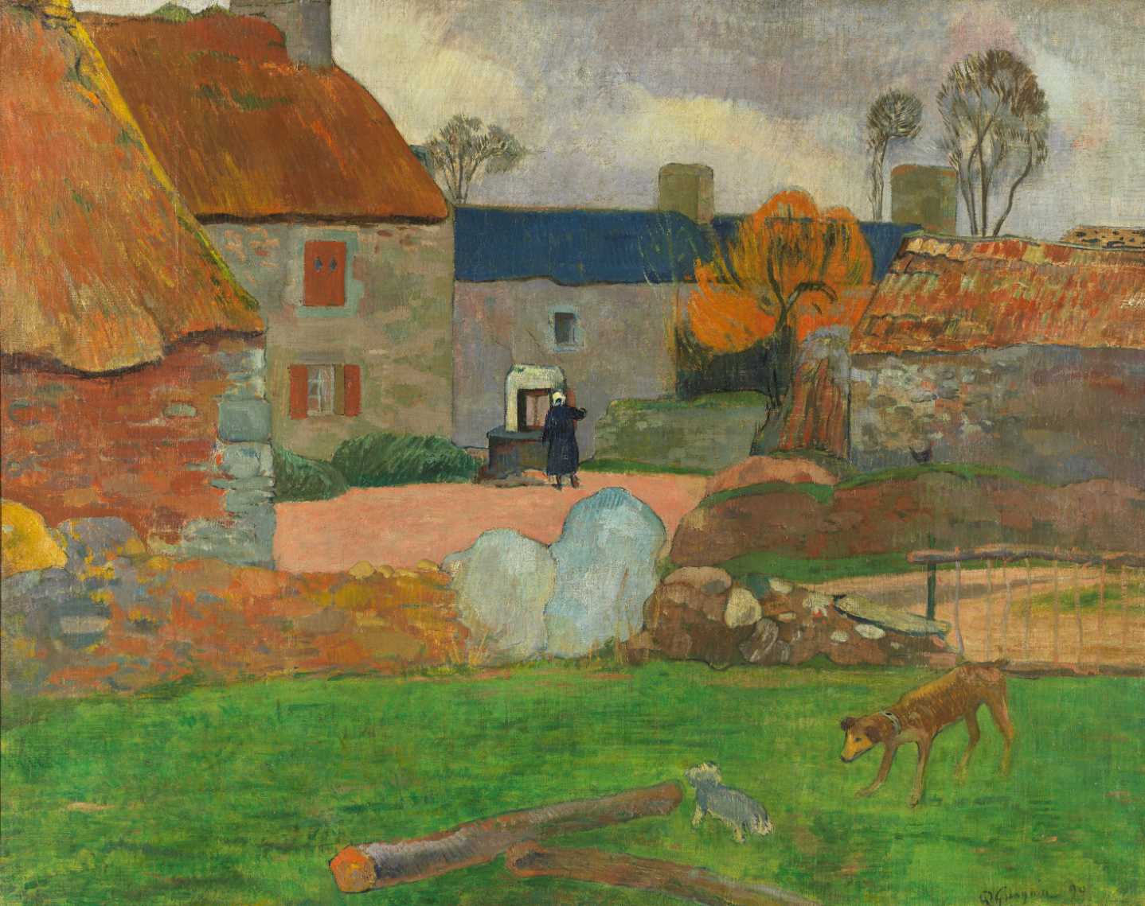National Gallery of Australia acquires significant painting by Post Impressionist master Paul Gauguin

**The National Gallery today announced the acquisition of *The blue roof* or *Farm at Le Pouldu* 1890 by Paul Gauguin (1848-1903), the first painting by the artist to enter an Australian public collection.**

*The blue roof* or *Farm at Le Pouldu* is currently on display in the major exhibition *Gauguin’s World: Tōna Iho, Tōna Ao*. The exhibition traces Gauguin’s artistic journey and global travel – from his Impressionist beginnings in 1873 to his final destination in French Polynesia. The newly acquired painting is a key example from his Brittany period. Following the exhibition, the work will join the permanent collection displays of the National Gallery to be appreciated by audiences for generations to come.

*The blue roof* or *Farm at Le Pouldu* captures an approach to colour and freedom of expression that characterises Gauguin’s subsequent work, hinting to the art yet to come. The picturesque scene of a country farmyard has simplified structure and form, the composition divided into planes, with colour used for definition. Gauguin’s bold use of orange, pinks and blues were highly modern for a work produced in the late 1800s, foreshadowing the developments of 20th century art.

The painting is among a small number of works painted by Gauguin at Le Pouldu on the Breton coast.At the centre of the composition, a woman is shown drawing water from a well, framed and almost subsumed by the rustic farm buildings. Gauguin varied his brushstrokes to capture a sense of the rough surfaces of the stone buildings, thatched roofs and the surrounding vegetation. The composition centres on the figure of the woman, dressed in dark blue with a white cap, and the well. A distinctive blue roof is characteristic of the rural architecture in Le Pouldu, and two dogs in the foreground provide further interest.

From July 1886 until his departure for Tahiti in April 1891, Gauguin travelled regularly between Paris, towns in Brittany and to the South of France, searching for a way to consolidate his style, as well places to live cheaply. He absorbed the region’s peasant traditions, music and especially woodcarving, and described scrutinising ‘the horizons, seeking that harmony of human life with animal and vegetable life through compositions in which I allowed the great voice of the earth to play an important part.’[1] The images of peasant life, the landscape and harvest scenes Gauguin painted in 1889 and during 1890 are some of the most radically simplified of his career.

The National Gallery holds seven prints by Gauguin in the collection, with the first gifted to the National Gallery by renowned Australian artist Sir Russell Drysdale in 1974. The acquisition of *The blue roof* or *Farm at Le Pouldu* has been brought to fruition with the extraordinary support of the National Gallery of Australia Foundation. It will be on show in the permanent collection galleries in late 2024.

**National Gallery Director Dr Nick Mitzevich said:** ‘*The blue roof* or *Farm at Le Pouldu* by the Post Impressionist master Paul Gauguinis an important acquisition for the national collection. It captures a key point in art history – the moment when the artist emerged as an intensely original master, taking Impressionist colour schemes and transcending them to be bolder and more daring.’

‘As the National Gallery, we aim to present Australian audiences with access to world-class art that inspires and educates. This work by Gauguin adds to the anchor works in the national collection from the past 100 years including by artists such as Claude Monet and Mary Cassatt through to Jackson Pollock and Louise Bourgeois.’

‘We are extremely grateful for the generosity of the National Gallery Foundation who made this acquisition possible,’ continued Mitzevich.

Since his death in 1903, Gauguin has left two enduring and conflicting legacies – his art and himself. Like other contemporary and historic artists, Gauguin’s life and art have increasingly and appropriately been debated here and around the world. In today’s context, Gauguin’s interactions in Polynesia in the later part of the 19th Century would not be accepted and are recognised as such.

*Gauguin’s World: Tōna Iho*, *Tōna Ao* is open at the National Gallery of Australia in Kamberri/Canberra until   
7 October 2024. The exhibition has been organised by the National Gallery of Australia, Canberra, The Museum of Fine Arts, Houston and Art Exhibitions Australia.

**EXHIBITION DETAILS  
*Gauguin’s World: Tōna Iho, Tōna Ao*  
Until 7 October 2024  
Ticketed**.  
Adult: $35 | Concession: $32 | Members: $27 | Kids (ages 5-16): $12 | Kids (ages 0-5): free  
Book [here](https://nga.gov.au/exhibitions/gauguins-world/#tickets)

**MEDIA KIT**  
Available [here](https://nga.gov.au/about-us/media/media-kits/gauguins-world-t%C5%8Dna-iho-t%C5%8Dna-ao/)

**MEDIA RELEASE**[Gauguin’s World: Tōna Iho, Tōna Ao arrives at the National Gallery of Australia | 27 Jun](https://nga.gov.au/about-us/media/media-releases/2024/gauguins-world-tona-iho-tona-ao-arrives/)

MEDIA ENQUIRIES

JESS BARNES

Communications Manager

M | +61 437 986 286

E | jessica.barnes@nga.gov.au or media@nga.gov.au

**ABOUT THE ARTIST**Born in Paris in 1848, Paul Gauguin’s voyages saw him travelling to parts of the world almost unimaginable to most people in the 19th century. His life as an intrepid traveller started in childhood when his family fled to Peru, escaping the 1848 revolution; they later returned to France, settling in Orléans. At 17, Gauguin joined the merchant marines and navy and adventured across the world. Back in Paris, he worked in a stockbrokers office and as an amateur painter, exhibiting his first landscape at the Paris Salon of 1876. Gauguin travelled to Brittany and Arles, Panama, the island of Martinique in the Caribbean, capturing the connections between people and their surrounding landscapes. In 1891 Gauguin left France for French Polynesia, living in Tahiti, where he created his most celebrated and compelling works. Although largely unrecognised in his lifetime, Gauguin’s art is now celebrated – like that of his friend and rival Vincent van Gogh. Gauguin’s work defines Post-Impressionism and Symbolism: it was highly influential for later artists such as Henri Matisse and Pablo Picasso. His vibrant use of colour and flattened decorative surfaces remain a motivating force for many artists in our times.

**PUBLICATION**  
*Gauguin’s World: Tōna Iho, Tōna Ao* inspires new ways of seeing and thinking about one of the most renowned artists of the 19th century. Featuring more than 150 colour reproductions, this publication is the first to explore Gauguin’s inner journey and quest to develop his own identity, surveying his practice from its Impressionist beginnings and Symbolist leanings to his Polynesian periods. 288pp. 300 x 245mm. Full Colour | Paperback. RRP A$59.95  
Download PDF [here](https://www.dropbox.com/scl/fi/hh9m15uw2sfhcxns58vwx/00_NGA_Gauguins-World_internals_FA-LOW-RES-SPREADS.pdf?rlkey=ivz0dj9fc3q5zv4r09a1337pl&dl=0).

**PODCAST**  
The Gauguin Dilemma, hosted by award winning Samoan-Australian journalist Sosefina Fuamoli, is a four-part podcast series exploring the social, political and art historical themes surrounding Paul Gauguin, asking... can you love the art but loathe the artist? Each of the episodes feature interviews with curators, loan institutions, art historians, community and museum representatives and technical experts including artists Yuki Kihari and Angela Tiatia, art historians Elizabeth C Childs and Dr Caroline Vercoe, author Daisy Lafarge and Polynesian knowledge holder Tahi Perinete.  
Listen [here](https://nga.gov.au/podcasts/the-gauguin-dilemma/).

**CAPTION:** Paul Gauguin, *Le toit blue* or *Ferme au Pouldu* (*The blue roof* or *Farm at Le Pouldu*) 1890, National Gallery of Australia, Kamberri/Canberra, purchased 2024 with the assistance of the National Gallery Foundation

1. quoted by Belinda Thomson, *Gauguin*, London: Thames & Hudson 2020, p.99