MEDIA RELEASE

28 AUG 2024

National Gallery announces international First Nations fellowship with Wereldmuseum, the Netherlands

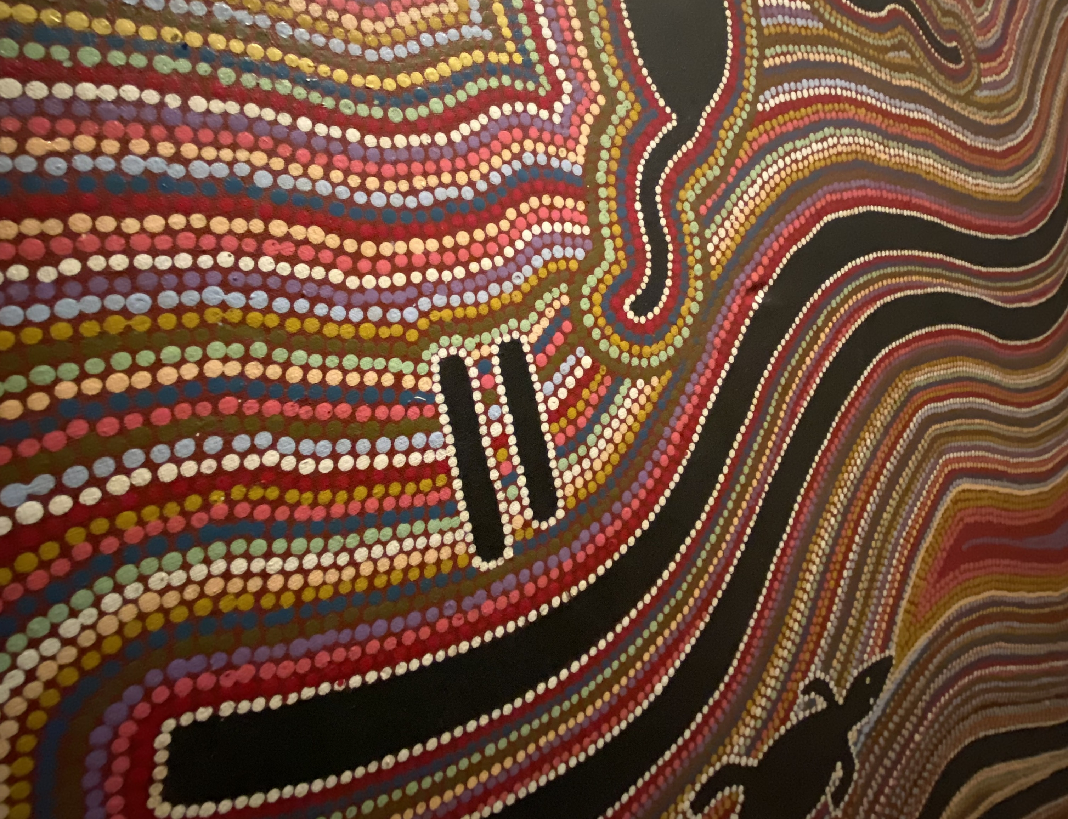**The National Gallery of Australia, Embassy of the Kingdom of the Netherlands (Australia) and the Wereldmuseum in Leiden have partnered to create a new international fellowship opportunity for First Nations arts workers.**

The **Nguluway Dhuluyarra Fellowship** aims to foster cross cultural learnings and new connections through engagement with Aboriginal and Torres Strait Islander people and cultures.

The Wereldmuseum holds the largest and most comprehensive collection of Aboriginal and Torres Strait Islander art administered by any public institution in Europe. Each year, the Nguluway Dhuluyarra Fellowship will support a First Nations arts worker to contribute knowledge, skills and curatorial experience to advance cultural understanding and engagement, specific to the Wereldmuseum’s First Nations collection of over 2900 works of art.

The first recipient of the Nguluway Dhuluyarra Fellowship is **Tina Baum** (Gulumirrgin (Larrakia)

/ Wardaman / Karajarri peoples), Senior Curator of First Nations Art at the National Gallery. Travelling to the Netherlands in October 2024 for a four-week period, Baum will collaborate and share her cultural knowledge and curatorial expertise on First Nations art with colleagues at Wereldmuseum Leiden.

**Fellowship recipient Tina Baum said:** ‘I am honoured to be the first curator to travel to the Wereldmuseum under the Nguluway Dhuluyarra Fellowship – which reflects a mutual respect for understanding and acknowledging First Nations cultures, histories and realities. This exciting new fellowship offers an opportunity for First Nations arts workers to share their cultural knowledge abroad while gaining access to the second largest collection of Aboriginal and Torres Strait Islander Art outside of Australia.’

The Nguluway Dhuluyarra Fellowship demonstrates a shared commitment between the National Gallery, Netherlands Embassy and Wereldmuseum to elevate First Nations voices and further understanding of Aboriginal and Torres Strait Islander cultures overseas.

**Dr Xenia Hanusiak, Snr Policy Officer Netherlands Embassy:** ‘The Nguluway Dhuluyarra Fellowship signifies another milestone achievement in cultural co-operations between the Netherlands and Australia and is a significant multi-year project in our dedicated First Nations' international cultural policy. By folding in the deep history perspectives of Indigenous peoples the fellowship recognizes our shared values of co-operation and knowledge exchange. We know that this fruitful fellowship will function as an instrument of change through what it means to be relevant to present and future society.’

**Prof. dr. Wonu Veys, Curator Oceania at Wereldmuseum:** ‘We are looking forward to the Nguluway Dhuluyarra Fellowship and to welcoming Tina Baum here in the Netherlands. We are excited to broaden our mutual networks. And we hope that we will develop longstanding relationships and connections with our first fellow, future fellows and their respective communities.’

The Nguluway Dhuluyarra Fellowship is an initiative of the Embassy of the Kingdom of the Netherlands Embassy (Australia), National Gallery of Australia and the Wereldmuseum (Netherlands).

**IMAGES**  
Available **here**

MEDIA ENQUIRIES

JESS BARNES

Communications Manager

M | +61 437 986 286

E | jessica.barnes@nga.gov.au or [media@nga.gov.au](mailto:media@nga.gov.au)

PARTNERS

**ABOUT NGULUWAY DHULUYARRA**The National Gallery engaged Paul Girrawah House, Ngambri (Walgalu), Wallaballooa (Ngunnawal), Pajong (Gundungurra) and Wiradjuri (Erambie) peoples, a local Ngambri/Kamberri/Canberra traditional custodian, to give a cultural name to the fellowship. **Nguluway Dhuluyarra** was chosen, meaning *coming together (Dhuluyarra), speaking truthfully (Nguluway)*, a name that reinforces the underlying premise to the fellowship. It provides a local cultural grounding through language and meaning to this international opportunity and connection with the Netherlands.

**ABOUT THE NGULUWAY DHULUYARRA FELLOWSHIP**The Fellowship is part of the Embassy of the Kingdom of the Netherlands in Australia Enrich-Embrace-Elevate Cultural program. In 2022, the cultural department of the Netherlands Embassy in Australia launched one of its most vital program activations: to embrace engagement with Aboriginal and Torres Strait Islander cultures. By embracing Aboriginal and Torres Strait Islander perspectives in programs, they recognise the wisdoms and heritage of the First Nations peoples of Australia as the oldest known civilization on earth, with ancestries dating back 75,000 years.

**ABOUT WERELDMUSEUM**  
Wereldmuseum believes that the world has no center, that it is one big network in which everything influences everything else. The three locations in Amsterdam, Leiden and Rotterdam [in the Netherlands] focus on themes that affect our daily lives. Through the collection and exhibitions on topics such as identity and equality, the museum explores the world around us to increase our understanding. Wereldmuseum prides itself on its many institutional research collaborations as well as individual collaborations with artists, fellows, activists, specialists and scholars from all over the world. Currently, the Wereldmuseum has a strong focus on indigeneity, global art and design, all connected with the museum’s ethnographic collections. Wereldmuseum is very honoured to welcome Tina Baum, the first fellow emerging from the Nguluway Dhuluyarra Fellowship and is very grateful to all parties involved for the collaboration.

**ABOUT TINA BAUM**  
Tina Baum, Gulumirrgin/Larrakia/Wardaman/Karajarri peoples, has over 35 years’ working experience in Australian Museums and Galleries. As the Curator of Aboriginal and Torres Strait Islander Art at the National Gallery of Australia (since 2005) and now newly appointed Senior Curator, First Nations Art, she has curated numerous exhibitions including the *Defying Empire: 3rd National Indigenous Art Triennial*, 2017 and *Ever Present: First Peoples Art of Australia*, 2021-24 national and international touring exhibitions. She is a writer and a recipient of numerous national and international leadership programs and fellowships. She is passionate about embedding Indigenous voices, perspectives and truth telling through Indigenising best practice methodologies and reasserting traditional language, cultural authority and agency within museums and galleries throughout Australia and internationally. Tina commences her fellowship in October 2024 for a 4-week period.

**ABOUT DR. XENIA HANUSIAK**Dr. Xenia Hanusiak is a festival director, curator, cultural diplomat, writer, and scholar who curates performance programs, literary festivals, and ideas summits across four continents for institutions and festivals from National Sawdust, the Film Society of the Lincoln Center in New York to the Beijing Music Festival. As a cultural attaché she is currently the Senior Policy Officer for the Netherlands Ministry of Foreign Affairs. She has held senior diplomatic roles, including a posting as a Cultural Attaché for the Australian Consulate-General New York. In 2022 she co-directed "Currents of Change: Redefining Cultural Diplomacy for the future we need." for Salzburg Global Seminar inviting sixty leaders from twenty-eight countries resulting in the Salzburg statement. She is currently the local President of the European Union National Institutes for Cultural Institutes.

**Image:**Image courtesy of Wereldmuseum

.